Critical Design Report

Haggis aerospace, University of Dundee

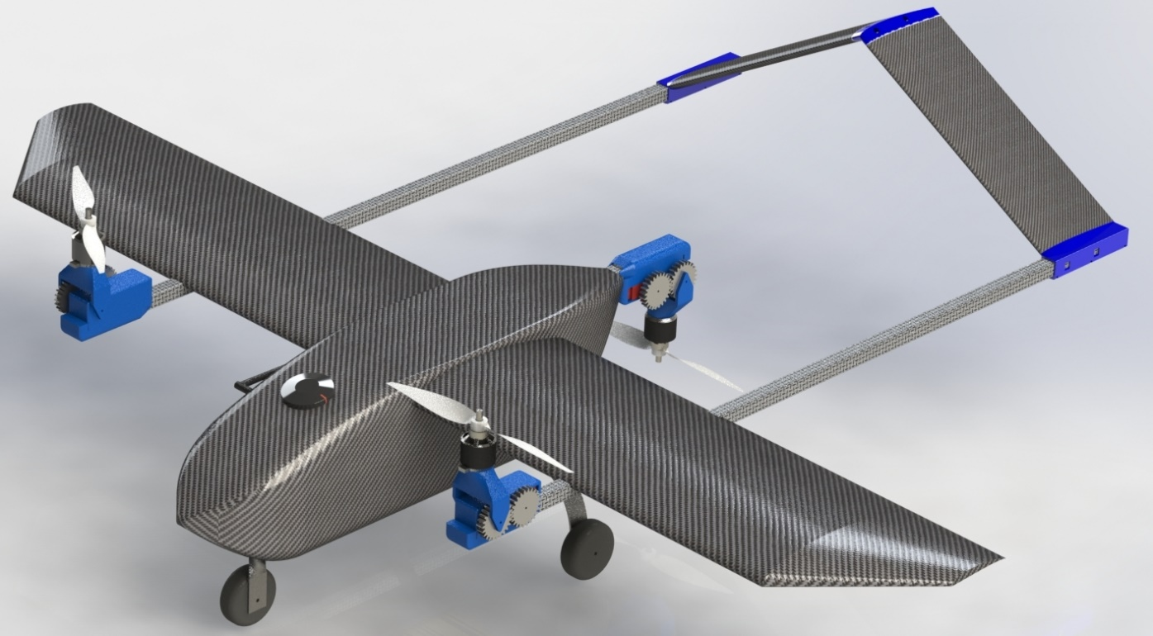

Haggis 5.0 “Dave”

Team Members

|  |  |  |
| --- | --- | --- |
| Chad Barnard | Mechanical Engineering | 2nd Year |
| Maksim Vassiljev | Mechanical Engineering | 3rd Year |
| Anton Parsons | Mechanical Engineering | 2nd Year |
| Josh Humphries | Mechanical Engineering | 1st Year |
| Michael Kiersten | Accounting | 1st Year |

Supervisor:

 Markus Pakleppa, Dr. of Biomedical Engineering 

Team lead:

Supervisor:

Description

The Haggis Aerospace team has designed a UAS with focus on speed, capable of vertical and conventional take-off and landing, navigation around waypoints, recognition of ground markers, safe delivery of payloads of up to 2 kg and gliding.

The design is a tri-motor tilt rotor UAS with 2 pullers and 1 pusher motors and a reverse V-tail.

The tilt rotor allows to combine both the convenience of VTOL and efficiency of a plane. VTOL reduces the reliance on runways and allows landing and delivery of fragile packages. Conventional landing gear is used for redundancy in case VTOL fails and is positioned in a tricycle configuration.

The UAV’s has a tilting motor mechanism allowing it to use its 3 high thrust motors to hover and to quickly transition into normal flight with minimum loss of efficiency, as all 3 motors will contribute to flight. The Tilt-motor mechanism allows the use of differential tilt for yaw control.

The UAS is designed to be highly modular, allowing it to be fully assembled in under 5 minutes, quickly replace parts, perform repairs and maintenance, access all electrical components with ease as well as to store the drone in a small container. Potentially, existing parts can be switched for parts specialised for certain missions, like different wings for different types of missions. VTOL motor mounts could be exchanged for fixed versions.

The drone is designed to be highly versatile and reliable. It is designed to be able to perform not only as a tilt rotor, but also as either fixed wing or copter, meaning that in case of a system malfunctioning, it can continue operation or finish the mission safely.

Image recognition tasks are carried out with a RaspberryPi 3b using contour detection techniques and a Support Vector Machine for classification of the target square. The target GPS coordinates are determined through geometrical solutions. The Raspberry Pi will communicate with the Pixhawk over a MAVProxy connection to provide the target coordinates to the GCS.

The Drone will communicate to the ground station using a telemetry module to perform mission control.

Changes since CPR

The aluminium is no longer available for parts as we couldn’t get access to the proper equipment. Hence most complex parts will be 3d printed and laser cut. The gimbal was removed to reduce complexity, the camera will be attached rigidly and the drone will manoeuvre, as well as use image stabilising algorithms to get the desired picture .

Contributions from sponsors:

Easy composites (carbon fibre discount) - 10% discount

Use of equipment and facilities - University of Dundee

RS-grassroots - 250£ worth of components from RS-components

T-motors- 30% discount

Dundee university student association – 1020£ entry fee and half of travel costs

Project Management

The Gannt chart below illustrates our progress so far against our project plan. Stricken through items are complete Half of a month were used as deadlines (15th of each month), and specific deadlines are listed on top. The red line shows current position. Items are subdivided into categories, and in each category the lower item is dependent on the higher item. The categories themselves follow this rule roughly as well.

Generally, not all milestones have yet been achieved due unforeseen availability issues for key resources that could not be compensated by adjusting the project plan. All the design is finished; however, the prototype manufacturing is just beginning, with just the composite manufacturing learning being done. With the return to on face-to-face learning, the already small team had less free time. The attempts to increase team resources failed. Another factor that slowed things down is the fact that materials took longer than expected to arrive, however now 90% of them are present.

To try to catch up it was decided to streamline the manufacturing process. Most importantly, there will be no separate prototype manufacturing, and the team will be making the final drone from the start, with all testing and validation being caried out on the final product with minor tweaking of parts along the way.

The Software part is also heavily reduced, the gimbal features are removed, being replaced by a more comprehensive search pattern, and the image recognition coding will not be developed from scratch but will rather use previous years code with minor tweaking.

Below is the updated Gantt chart that better shows what the rest of the time will be spent on.

The manufacturing Will start, however now, no prototype will be made. Parallel to manufacturing the components will be tested for strength. At the same time, the separate drone will be used for mission testing, and once the Drone is bult, tests will begin on it.  
as soon the drone is able to perform the basic mission, The image recognition development will begin. There is already code that works, but it needs to be reviewed. Also, when the drone will be able to perform the mission, a transport Container will be manufactured.

We believe that during April, when university load on the team will be lifted, that the team will get back on track and finish the necessary manufacturing and testing.  Problems are expected so minor tweaking’s of the design will be executed as problems arise.

Risks assessment

|  |  |  |
| --- | --- | --- |
| **Risk type** | **Risk** | **Mitigation** |
| Resourcing | Not having enough time and people to do manufacturing and testing due to all team members being out of town and the small size of the team | Reduce the complexity of the project while still reaching the requirements. Continue trying to increase the team size. |
| Skills | The use of new manufacturing techniques (carbon fibre vacuum wrapping) proofs to challenging | Roll back to simpler manufacturing techniques, such as Wet Lay-Up instead of vacuum lay-up or worst case, get rid of CF (design allows it) |
| New team members lack the skills to design parts. | Organised learning materials and workshops to get new members up to speed. Organise meetings with previous team members to pass on knowledge. |
| Procurement | Lack of funding to get parts | Have funds saved from not having a physical fly off last year, reusing existing parts, continuously contacting sponsors. Search for sponsors should improve with the completion of the design report. Use similar parts on hand |
| A shortage of a certain material in the market appears (3d printing filament, electronics) | Find materials on international shops, second hand, try to borrow from university or sponsors, use different materials if possible |
| Manufacturing | Lack of access to university workshop | Use a possible alternative locations or workshop rental places. |
| Lack or Malfunction of university equipment like laser cutters and cnc-mills | Off source laser cutting and cnc-foam cutting. Worst case scenario, manufacturing by hand |
| Running out of materials | Prebuy materials to have slightly more than we need |
| Malfunction of a key piece of equipment (3d printer, battery charger) | Try to fix said equipment, Contact university to try and borrow equipment, worst case buy new equipment |

Key requirement review

Below is a table of key requirements. Some “shall” requirements that just require a confirmation are not included to fit in 2 pages

|  |  |  |
| --- | --- | --- |
| ID | Requirement | Verification |
| 3.1.1 | MTOM mass <= 10kg | Detailed weight budget has been  calculated of 8 kg ± 10% as contingency |
| 3.1.3 | have an externally removable link to isolate power to motors. | The externally removable link is located on the side of the nose of the drone |
| 3.1.4 | The payload shall comprise the AirDropBox Micro system filled with builders sand | The fuselage was designed around the dimensions of the AirDropBox Micro and calculations assume the weight of the payload of 2 kg |
| 3.1.5 | Rapid loading of Aid Package, Automatic deployment | Payload loaded from below and held by a hatch and release pin controlled by servo. |
| 3.1.7 | All radio equipment and datalinks shall comply with Ofcom IR 2030 – UK Interface Requirements 2030 Licence Exempt Short Range Devices | GCS Downlink using a 433MHz connection limited to <= 10mW E.I.R.P. as per IR 2030/1/10 Radio Uplink will be on 2.4GHz 'Spread Spectrum' connection with frequency hopping modulation limited to <=100mW E.I.R.P as per IR 2030/7/23 |
| 3.1.8 | Master controller shall be set up to operate in Mode 2 configuration( yaw/throttle on left-hand stick, roll/pitch on right-hand stick.) | FrSky Taranis I6X is setup in Mode 2 configuration |
| 3.1.9 | A Flight Termination System (FTS) shall be incorporated. FTS to be automatically initiated after 5 seconds lost Uplink and 10 seconds after lost Downlink.FTS shall also be initiated by breach of the Geo-fence. The FTS shall be capable of activation via the Master Controller | Depending on the stage of the flight, FTS shall either (after vtol) cut throttle and initiate a spiralling descent or (during vtol) set motors to idle and gently descend.  Automatic activation of FTS is configured in the Pixhawk. The master controller has a trigger setup to initiate FTS |
| 3.1.11 | In the event of a crash, the UA shall make an audible and visual alert to improve ease of UA location. | Pixhawk and wing leds will flash and the onboard buzzer will activate. The uas will be covered in the bright colours in case electronics fail. |
| 3.1.13 | Teams shall design and make a Storage Container for transporting their UA | Storage container will be constructed out of plywood filled with foam with cut-outs for the UA parts |
| 3.1.14 | The design of the UA shall ensure that the Tracker and Power Logger can be easily fitted and removed. | UA’s fuselage has free space next to the pixhawk to include multiple power loggers. The added weight will not impact ua’s performance significantly |
| 3.2.1  3.2.2 | Mission requirements are met, The total Mission time is limited to 15 minutes | The UA is designed to meet the core requirement of delivering payload to drop zone via defined waypoints following the medium route within the time limit and performing a climb and glide test. Additional speed trial, marker ID detection and area search will be attempted. Our calculations show a mission time of 8 mins 20 seconds, which is more than enough for all the tasks and gives extra time for delays |
| 3.2.1.2 | The UA to take off and land from within a 30 m x 30 m box to be capable of operating from both short grass and hard runway surfaces. | Vtol option allows the uav to take of and land from virtually anywhere |
| 3.2.3.1 | the radio equipment including data links, shall be capable of reliable operating ranges beyond 500 m. | 433 Mhz transceiver is capable of up to 3km connections, however <10mW specification makes max distance unknown. Test’s will be run to confirm it is above 500m |
| 3.2.4 | The UA should be designed to operate in winds of up to 20 kts gusting to 25 kts, and light rain.The UA should typically be capable of take-off and landing in crosswind components to the runway of 5 kts with gusts of 8 kts. | the UAS can operate in 20-25kt winds safely as the thrust required to maintain cruise speed is partial of maximum thrust. Vtol allows to land precisely in high crosswinds. All electronics are shielded from rain by the waterproof fuselage. |
| 3.3.1 | Compliance with UK CAA Drone Regulations | Team pilot will be registered as an operator and the rest of the team as remote pilots. |
| 3.3.4 | Batteries shall contain bright colours, at least 25% of the upper, lower and each side surface of the aircraft shall be a bright colour to facilitate visibility in the air, and to aid retrieval of the aircraft in the event of a crash and each side surface of the aircraft shall be a bright colour to facilitate visibility. | The UA’s wing will have bright red tape and led strips will be attached at the wing tips to facilitate visibility. Battery already in bright colour. |
| 3.3.5 | The UA shall remain within Visual Line of Sight, no greater than 500m horizontally from the Pilot, below 400 ft AGL;The UA shall not be flown within 50 m of any person,UA shall remain in controlled flight and within the Geofence boundary of the Flying Zone; | The boundaries of the flight zone shall be incorporated into the pixhawk and FTS will be initiated in case of a breach. In case UA loses control, FTS shall be activated. |

Design Description

Airframe

The fuselage was designed around the dimensions of the payload to ensure low air resistance and that centre of gravity of the payload would be on the same axis with the centre of gravity of the plane to reduce the difference in stability with and without the payload. The Fuselage itself is comprised of a carbon fibre shell and a plywood skeleton. The shell is 1.5 mm thick, which for this size has great rigidity and light weight, while not taking up a lot of space. Hatches will be cut out on the top to access the electronics, which will be hinged and stay closed using flexible hooks. The Plywood increases rigidity and provides a base for electronics and is really easy to manufacture using laser cutting.

The plywood panels have a hexagonal pattern cut-out on them to reduce weight but keep them relatively strong. They are also a great guide for manufacturing, as the holes for the other parts will be laser cut on the plates allowing for easy alignment.

The Main 3d printed connectors and the Pixhawk flight controller are secured on the top panel, the raspberry pi and the camera are attached to the front panel, with the hatch release mechanism on the back panel

3 square Carbon fibre spars are secured to the top plate, 2 of the wing, 1 of the rear motor and are secured by 20% honeycomb structure infill ABS 3D-printed connectors which clamp shut around the spars using M3 screws. A Carbon fibre spar used for the rear pusher motor extends from the main body towards the tail. 2 Thick short spars are used as the holders for the wing spars.

All of the spars are connected Using clamping, meaning a minimum number of holes that which act as stress concentrators, weaking the carbon fibre need to be drilled. This also allows many parts to quickly disconnect for transportation. Where parts don't require disassembly, they are epoxied to the spars for extra security.

From the sides of the main body, two square wing spars protrude 600mm to each side. The front wing spar is 20mm in diameter. It is there to take the load off of the wing and to serve as a pivot when the wing is rotated. The second wing spar has a 8mm diameter. It is there to reduce twisting of the wing, provide support against torsion, add rigidity, and to help with alignment of the wing. Both wing spars slide into the fuselage connection spar and are secured with draw latches from the inside.

Attached to the wing spars, underneath the wing are another 2 connectors that hold the Tail spars.

The reason for the main structure being made from square carbon fibre spars is that they are both light and very strong. The carbon fibre spars form the skeleton of the design, and all the stresses are redirected on them. Square spars fit nicely together and don’t allow slipping or twisting

The wing and tail stabilisers are made out of a hotwire cut high density foam wrapped in thin layer of carbon fibre composite. This provides increases strength and allows us to store the batteries, servos and esc’s in the wing

The wing electronics are easily accessible thru cut out hatches similar to the fuselage ones, that are held by magnets. Some airflow will be directed thru holes near the motor mounts into the battery compartment for cooling.

The battery is custom made out of 16 “18620” lithium-ion cells spot welded together arranged in a 4 series, 4 parallel configuration, divided between 2 wings.

Motor mounts

Blind connectors are used to connect all the wires when the wings slide onto to the fuselage, and simple by hand connections are used for attaching the motors

The Landing gear is made from thin steel sheets that are bent in an arc. Landing gear attaches to the side of the fuselage with screws, close to the plywood support. The wheels are of the shelf model aircraft parts with foam tyres

The connectors and motor mounts are 3D printed as this is both a cost-effective way of making the necessary complex shapes and again the materials are much lighter than a metal alternative. Structural analysis simulations were run in solidworks on all 3d printed parts and later physical loading tests showed that 3d printed parts can withstand up to 400% of the expected load.

The tail was designed in an inverse-V configuration, this was done to minimise turbulence generated by the rear propeller. The tail consists of three main types of parts; The tail mounts, which are a 3d printed part that clamp on to the spars attached to the wings, the aerofoils (including the rudders) which are made of carbon fibre, and the connecting piece, another 3d printed part which connects the two aerofoils and sits in the middle of the tail. These parts are fastened together with M3 nuts and bolts, which was decided upon for ease of assembly and disassembly. The aerofoils contain a pair of carbon fibre spars, which have inserts added for M3 nuts to allow fastening to the mounts and connecting piece. The empty space inside the aerofoils will be filled with foam.

The 3D printed parts will be produced in-house, mainly on the Prusa i3 Mk2 printers we have at our disposal, using PET filament. The carbon fibre components (except for the spars) will also be manufactured in-house.

Aerodynamic calculations

XFLR5 was used to decide on the aerofoils, wing size, tail position and other aerodynamic specifications. The design requirements were evaluated, and our targets were a cruise speed of 52,5 KIAS (27.5 m/s), 8kg mass and high lift for gliding. After simulating different configurations, Air foil SG6043 was chosen for the wing and a NACA 0012 for the tail positioned 900mm away from the leading edge of the wing. The CG was estimated to be roughly in plane with the payloads CG, and an analysis of the aerodynamic characteristics was undertaken. The cases analyse the UAVs performance at target cruise speed of 58,3 KIAS (30 m/s) and at minimum cruise speed required, using XFLR5’s Ring vortex analysis method and using the assumption that the drag coefficient of the body of the plane is 0.3 by considering a square plate with an area of 0.4 m2 the drag was overestimated due to the limitations within xflr5 to simulate the body correctly. Once the CG from the solidworks model was determined, another analysis was run to correct for the previous estimation and the relative position of the tail was adjusted slightly

Fig smth. Performance of the aircraft with the payload at max allowable speed (blue) and at stall speed (yellow) the payload obtained from xflr5

It is to be noted that the resulting calculations are an underestimate of real-world performance in terms of lift, as the simulations do not consider the additional airflow coming from the props which would be at a much higher speed relative to the global airspeed as well as the fact that body drag is overestimated. Overall The coefficient of lift to coefficient of drag ratio (Cl/Cd) was at **~**19  with the payload. This relatively low ratio is due to the expected speed of the drone

Propulsion

The UAS is powered by 3 T-Motor AT2826 KV900 motors. Two motors will be fitted with APC 12x6 propellers, and the rear motor will be fitted with the equivalent pusher propeller. This motor was chosen because it has a lot of thrust at full throttle and high efficiency at low throttle. This motor also has a high efficiency at the desired airspeed.

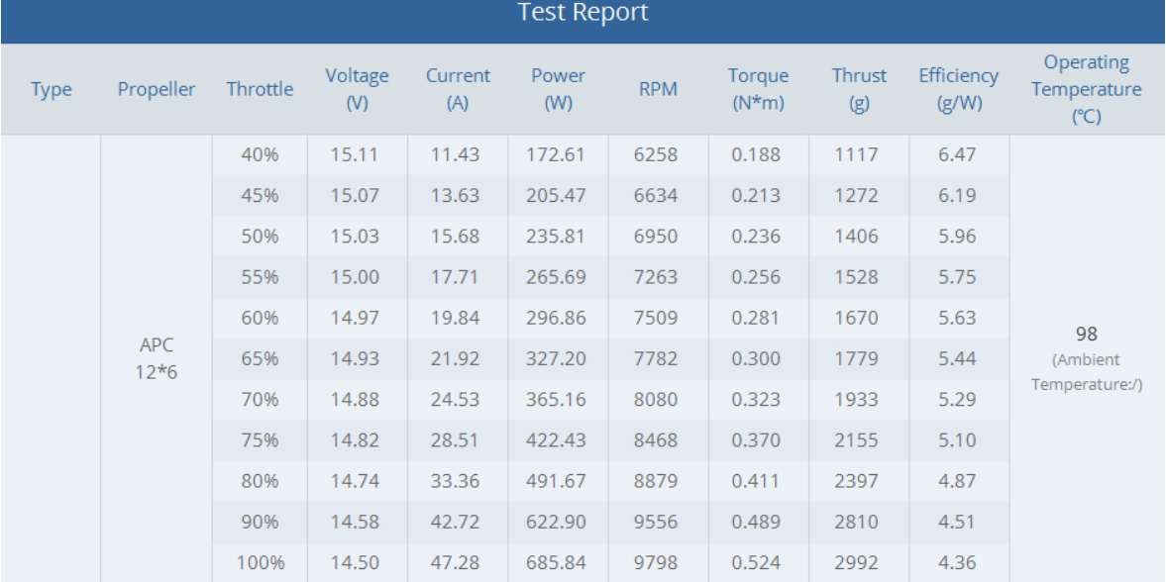 The motors are rated for 3s or 4s with li-ion batteries of 16.8V. Calculations show that during VTOL the motors can draw up to 57 Amps and 820 Watts in per motor.

|  |  |  |  |
| --- | --- | --- | --- |
| Main Thrust | | |  |
|  |  | Total | System |
| V nominal | 14.6 | 43.8 | 4s(eqv.) |
| A | 47.3 | 141.9 |  |
| P | 690.58 | 2071.74 |  |

To safely operate at such high power, wire gauge 9 is used and a proprietary battery is made using 18650 35E 3300mAh cells. These cells are used as they have a good capacity to weight ratio as well a hight sustained discharge rate. To maintain cruise speed a thrust of 22 N or 20% of full thrust were required. Based on that and estimates of time required for each flight stages the number of Amp Hours was calculated:h

|  |  |  |  |  |  |  |  |  |
| --- | --- | --- | --- | --- | --- | --- | --- | --- |
| Activity | Description | Throttle | Total Amps | Thrust | Time in s | Ah | Total Ah | 10.5 |
| 1 | Takeoff | 1.0 | 141.9 | 88.0 | 20.0 | 0.8 |  |  |
| 2 | Travel | 0.4 | 56.8 | 35.2 | 270.0 | 4.3 |  |  |
| 3 | Cruise | 0.4 | 56.8 | 35.2 | 270.0 | 4.3 |  |  |
| 4 | Land | 1.0 | 141.9 | 88.0 | 20.0 | 0.8 |  |  |

The calculations show that roughly 10.5 Amp Hours are required for the mission. The calculations are not very precise, so to compensate for it a 13 Ah Battery was chosen. This is constructed from 16 cells arranged in a 4 series, 4 parallel configuration which allows for a high voltage as well as peak and continuous current. The battery cells will be split between the two wings to increase the potential space in the fuselage for cargo whilst keeping the centre of mass close to the centre of the craft.

Flight controls

The UAV is designed to take off vertically and then transition to forward flight. For this the motors must be rotated. A system was designed for this purpose from scratch. It consists of two main components; the housing and the bracket. The housing is directly attached onto the tail spar which traverses through the main wing. It contains the servo motor that rotates the bracket with the main motor. The housing is made up of two main large components held together using M3 screws and bolts. The bracket is a singular piece designed to hold the motor and to rotate relative to the main housing. The system rotation is done by the servo motor and a set off two gears. The first is directly fused with the bracket and the second is attached to the servo motor. When the servo motor rotates the gear attached to it, puts a torque onto the gear on the bracket. As these two are fused the whole bracket with the motor attached to it rotates. It does this around an axis which consist of a long smooth aluminium bolt that is attached to opposite sides of the bracket and goes through the housing thus linking the two parts together. Except for the servo and the bolts all of the parts of the motor rotator system are designed to be 3D-printed. This decision has been made to reduce manufacturing costs and to allow for many parts to be re-designed and tested relatively quickly were this necessary. The reason for using gears instead of the servo is that even though the gears are of a one-to-one ratio, they along with the aluminium axis redirect all of the forces except for the torque away from the servo motor reducing wear and tear on it.

Three of motors are used in the UAV. Two of them will be attached to the main wing which will be puller motors and thus for the vertical flight will rotate 90° upwards. The third motor is attached behind the main body of the UAV. It will be a pusher and thus its rotation will be downwards instead. However, this does not affect the design, just the orientation of the motor rotator during assembly. Even though the design allows for this on all three rotators only the front two will be allowed to rotate up to an extra 20°. This is so that when in vertical flight, thrust vectoring can be used to control the yaw of the aircraft. Roll and pitch will be controlled using differential thrust.

During horizontal flight traditional flaps in the wings are used to control the aircrafts orientation. The difference being that since a reverse V-tail is used the flaps on it are used to control both the yaw and the pitch.

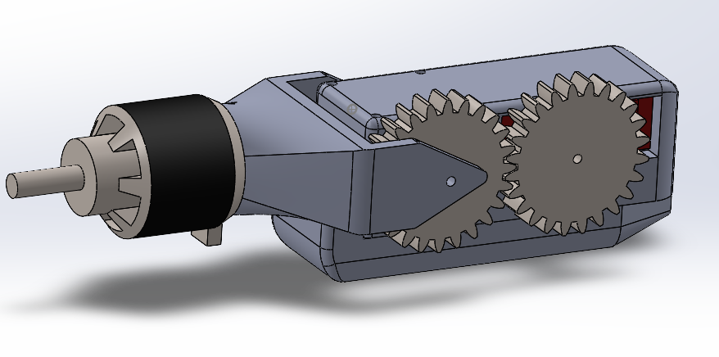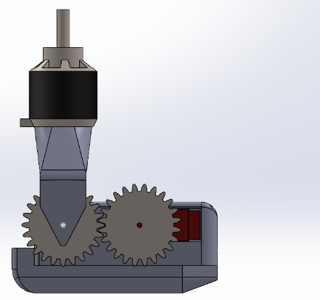

Navigation and mission control

Navigation is controlled by the ground station and controls are given to the UAS. The mission control sends GPS coordinates to the UAV which then follows the designated path. Holybro telemetry radios are used to transfer data between the station and the UAS. The radios themselves run at a baud rate of 57,600 and between a frequency of 433,050 and 434,750 Hz.

Sensors

The flight controller used will be a Pixhawk 2.1 cube. This will be running a modified version of Ardupilot and has built in, redundant sensors for altitude, attitude, compass directions and support for external sensors. A Here GNNS GPS module will be used for both ground speed calculations and Lat-Lon positioning with an accuracy of +- 30cm. A 433Mhz module will relay telemetry to a laptop on the ground running the ground station running a combination of QGroundControl and Mission Planner while the uplink will run on 2.4Ghz spread spectrum going from a Taranis I6X transmitter to a FRSky L9R long-range receiver, capable of line-of-sight range in excess of 3Km.

Both these systems are ROHS compliant and legal for use within the UK.

The telemetry and rc antennas and the GPS are positioned are positioned on the outside of the uas, as carbon fibre can block signals

Image Processing

The image processing is handled by a Raspberry Pi with all the code using python as the main coding language. To detect the colour of the target basic colour detection is used. In Currently the software can determine colour up to 5m away using a normal webcam at scale with roughly 80 percent reliability. It can process images in roughly 2 seconds. More tests are planned to confirm accuracy at further distances with intended equipment rather than on a test bed.

Autonomy

Mission planner is used along with Ardupilot to allow the UAV to fly independently. The onboard sensors allow the plane to accept a predefined path and fly along it as instructed by the ground station. The GPS coordinates are processed on the Pixhawk cube onboard the UAV which controls the UAV. The onboard camera and a raspberry pi 3b are used to detect coloured markers and convert the data into coordinates using the position of the drone and trigonometry.

Cargo Carriage

The fuselage is designed to hold the payload within itself with the carbon fibre and plywood acting as a slot for it. The parachute release cord is inserted and attached to the carbon fibre spar from the inside. Then the payload is inserted from the bottom of the drone The bottom door is then closed and while the system is powered off, a hook attached to a servo Is manually moved in position. When the system gets power, the servo will activate and will lock the hatch. When the drop point is reached the servo activates again, this time releasing the hook, the weight of the payload opens the bottom door and the cargo is released, the parachute release cord is pulled. Once the cargo has fallen out the force of airflow over the open door will close it back up enough for a magnet, located on the body of the plane, to attach to the door closing it shut. The parachute release cord appeared really stiff, so the parachute will be modified to be able to release with less force, and the cord will also be shortened to reduce the risk of getting caught in the motor. The parachute will be opened immediately after release at 10 m above ground and will slow down the payload to 9.72 KIAS (5 m/s).

Flight termination System

The purpose of the FTS is to return the UAS to the ground in a quick controlled descent. The FTS will be built into the pixhawk and will be activated if:

* The UAS breaches the geofence.
* The UAS loses its data up-link with the ground station for greater than 5 seconds.
* The UAS loses its data down-link for greater than 10 seconds.
* Manually activated via the mission planner.
* Manually activated via Master controller.

When FTS activates, depending on which stage of the flight it is activated, the following happens: If activated during a VTOL phase, the motors will cut to idle and will begin a prompt, controlled vertical decent to the ground. If activated during horizontal flight, the motors will be shut off and control surfaces will be set to allow for a gentle spiral descent towards the ground. The UAS will then start indicating its position via onboard LEDs and buzzer.

The FTS will be implemented by including a “FTS” mode into the firmware with pre-set parameters for setting the pitch and roll angles which will automatically carry out the correct actions bases on its own internally reported state.

Each battery pack will have an independent isolation switch as well as the main isolation switch which will cut power to the UAS.

Innovation

The 2022 UAS will consist of a carbon structure which will help to improve the durability of the system. Working with carbon fibre is a new technique for the team this year which posed interesting challenges for production and safety. Carbon fibre also allowed us to create more complex lightweight components that could not be effectively made with foam which was our previous manufacturing method. Foam will still be used to create moulds for some carbon fibre parts, some of which will be CNC milled to improve precision and repeatability allowing for smoother surfaces in contact with the air. The UAS will also feature proprietary battery packs which are placed inside the wings to increase the potential space in the main body of the craft for cargo and control equipment and utilise previously unused spaces. The placement of the batteries close to the body will not move the COM too far outboard to destabilise the craft.

The UAS will also feature articulated motor mounts which will allow for vertical take-off and landing and horizontal flight with the same motors. This year's design also allows for yaw control through differential pitching of the front mounts.

Weight and Costs Breakdown

We combined both weight and cost breakdown in the same table, so that is why it uses 3 pages.

|  |  |  |  |  |  |  |  |  |  |  |
| --- | --- | --- | --- | --- | --- | --- | --- | --- | --- | --- |
|  | | | **Total Weight** | **6469.3** |  |  |  |  |  |  |
|  |  |  | **Total Cost** | **2444.152833** |  |  |  |  |  |  |
|  |  |  | **COTS** | 927.224 |  |  |  |  |  |  |
|  |  |  |  | (grams) | (gbp) |  |  |  |  |  |
| I | II | III | Description | Unit Weight | Unit Price | Sub Qty | Total Qty | Total Weight | Total Cost | COTS? |
| X |  |  | Wing Assembly |  |  |  | 2 | 6469.3 | 1222.076417 |  |
|  | X |  | Wing |  |  | 1 | 2 |  |  |  |
|  |  | X | Carbon fibre tube 22mm od 685 mm (main spar) | 94 | 18.286075 | 1 | 2 | 188 | 36.57215 | no |
|  |  | X | Carbon fibre tube 8mm od 715mm (secondary spar) | 34 | 3.69655 | 1 | 2 | 64 | 7.3931 | no |
|  |  | X | Polysterine foam | 50 | 6.22 | 1 | 2 | 100 | 12.44 | no |
|  |  | X | 3d printed parts | 20 |  | 1 | 2 | 40 | 0 | no |
|  |  | X | Resin (50 gramms) | 50 | 0.54 | 1 | 2 | 100 | 1.08 |  |
|  |  | X | CF Cloth 200g/m^2 (58000 mm^2) | 11.6 | 12 | 1 | 2 | 23.2 | 24 |  |
|  |  | X | m3 screws | **1** | 0.04 | 8 | 16 | 16 | 0.64 | no |
|  |  | X | m3 washers | **1** | 0.04 | 8 | 16 | 16 | 0.64 | no |
|  |  | X | m3 nuts | **1** | 0.04 | 8 | 16 | 16 | 0.64 | no |
|  |  | X | Latch | **6** | 1.15 | 1 | 2 | 12 | 2.3 | yes |
|  |  | X | VGA connector (pair) | **3** | 1 | 1 | 2 | 6 | 2 | yes |
|  | X |  | Aileron Mechanism |  |  |  | 1 | 0 | 0 |  |
|  |  | X | Servo MG90S | **14** | 4.83 | 1 | 2 | 28 | 9.66 | yes |
|  |  | X | Hinges | 2 | 0.3 | 3 | 6 | 12 | 1.8 | yes |
| X |  |  | Motor mounts |  |  |  | 3 | 0 | 0 |  |
|  |  | X | Servo Paralax standard | **44** | 13.5 | 1 | 3 | 132 | 40.5 | yes |
|  |  | X | Apc 12x6 prop | 45 | **5.13** | 1 | 3 | 135 | 15.39 | yes |
|  |  | X | AT2826 Long Shaft T-motor KV900 | 175 | **66.62333333** | 1 | 3 | 525 | 199.87 | yes |
|  |  | X | 3d printed Motor Mounts | 31 |  | 2 | 6 | 186 | 0 | no |
|  |  | X | ESC - Hobbywing Xrotor 40A | **32** | 15.12 | 2 | 6 | 192 | 90.72 | yes |
|  |  | X | m3 screws | **1** | 0.04 | 6 | 18 | 18 | 0.72 | no |
|  |  | X | m3 washers | **1** | 0.04 | 6 | 18 | 18 | 0.72 | no |
|  |  | X | m3 nuts | **1** | 0.04 | 6 | 18 | 18 | 0.72 | no |
| X |  |  | Electrical Components |  |  |  | 1 | 0 | 0 |  |
|  |  |  | 16 PCS 3300MAH, 3.7V | **768** | 57.284 | 1 | 1 | 768 | 57.284 | yes |
|  | X |  | Pixhawk 2 cube | **95** | 250 | 1 | 1 | 95 | 250 | yes |
|  | X |  | GPS Module | **32** | 22.88 | 1 | 1 | 32 | 22.88 | yes |
|  | X |  | Camera (RPi Camera Module V2) | 10 | 29 | 1 | 1 | 10 | 29 | yes |
|  | X |  | Hollybro telemetry module (set of 2) | **23** | 35.55 | 1 | 1 | 23 | 35.55 | yes |
|  | X |  | Raspberry Pi | **46** | 53.83 | 1 | 1 | 46 | 53.83 | yes |
| X |  |  | Wires (calculated in seperate sheet) | 250 |  |  | 1 | 250 | 0 |  |
| X |  |  | Fuselage assembly |  |  |  | 1 | 0 | 0 |  |
|  | X |  | Structure |  |  |  | 1 | 0 | 0 | no |
|  |  | X | Birch 3mm plywood (31000mm^2) | **33** | 4.666666667 |  | 1 | 33 | 4.666666667 | no |
|  |  | X | carbon fiber tube 25od 170mm | 42 | 6.2305 |  | 1 | 42 | 6.2305 | no |
|  |  | X | carbon fiber tube 10od 170mm | **34** | 1.7 |  | 1 | 34 | 1.7 | no |
|  |  | X | carbon fibe rtube 20od 470mm | **90** | 26.69 |  | 1 | 90 | 26.69 | no |
|  |  | X | 3d printed connectors | **67** | 0 | 1 | 1 | 67 | 0 | no |
|  |  | X | Resin | 75 | 1.08 |  | 1 | 75 | 1.08 |  |
|  |  | X | CF Cloth | 100 | 18 |  | 1 | 100 | 18 |  |
|  |  | X | Polysterine foam | 0 | 18.66 |  | 1 | 0 | 18.66 | no |
|  |  | X | m3 screws | **1** | 0.04 | 21 | 12 | 12 | 0.48 | no |
|  |  | X | m3 washers | **1** | 0.04 | 21 | 12 | 12 | 0.48 | no |
|  |  | X | m3 nuts | **1** | 0.04 | 21 | 12 | 12 | 0.48 | no |
|  | X |  | Landing gear |  |  | 1 | 1 | 0 | 0 | no |
|  |  | X | Steel flat bar (2mm) | 70 | 2 | 3 | 3 | 210 | 6 | yes |
|  |  | X | Wheels | 35 | 2.33 | 3 | 3 | 105 | 6.99 | yes |
|  | X |  | Payload release mechanism |  |  | 1 | 1 | 0 | 0 | no |
|  |  | X | Airdropbox micro with sand | 2000 |  | 1 | 1 | 2000 | 0 | no |
|  |  | X | Paralax servo | 40 | 4.91 | 1 | 1 | 40 | 4.91 | yes |
|  |  | X | Plastic Hinge | 2 | 0.48 | 1 | 1 | 2 | 0.48 | yes |
|  |  | X | CF sheet | 60 | 0 (cutout of fuselage) | 1 | 1 | 60 | 0 | no |
|  |  | X | Neodinium magnets | 10 | 1.03 | 2 | 2 | 20 | 2.06 | yes |
| X |  |  | Tail assembly |  |  |  | 1 | 0 | 0 |  |
|  | X |  | Square carbon fiber spar 20mm 1200mm | **185** | 34.5 | 2 | 2 | 370 | 69 | no |
|  | X |  | Square Carbon fiber spar 10mm 380mm | **23.125** | 3.4 | 4 | 4 | 92.5 | 13.6 | no |
|  | X |  | polysteryne foam | 50 | 6.22 | 1 | 1 | 50 | 6.22 | no |
|  | X |  | 3d printed connectors | 100 |  | 1 | 1 | 100 | 0 | no |
|  | X |  | Resin | 50 | 1.06 | 1 | 1 | 50 | 1.06 |  |
|  | X |  | CF Cloth | 11.6 | 12 | 1 | 1 | 11.6 | 12 |  |
|  | X |  | Servo MG90S (2kg/cm) | 14 | 1.5 | 2 | 2 | 28 | 3 | yes |
|  | X |  | m3 screws | **1** | 0.04 | 10 | 12 | 12 | 0.48 | no |
|  | X |  | m3 washers | **1** | 0.04 | 10 | 12 | 12 | 0.48 | no |
|  | X |  | m3 nuts | **1** | 0.04 | 10 | 12 | 12 | 0.48 | no |
| X |  |  | Other |  |  |  |  | 0 | 0 | no |
|  |  |  | RC-transmiter |  | 93 |  |  | 0 | 93 | yes |
|  |  |  | 1 roll of ABS fillament |  | 23.5 |  |  | 0 | 23.5 | no |
|  |  |  | ducttape |  | 4 |  |  | 0 | 4 |  |
|  |  |  |  |  |  |  |  | 0 | 0 |  |

## System architecture diagram

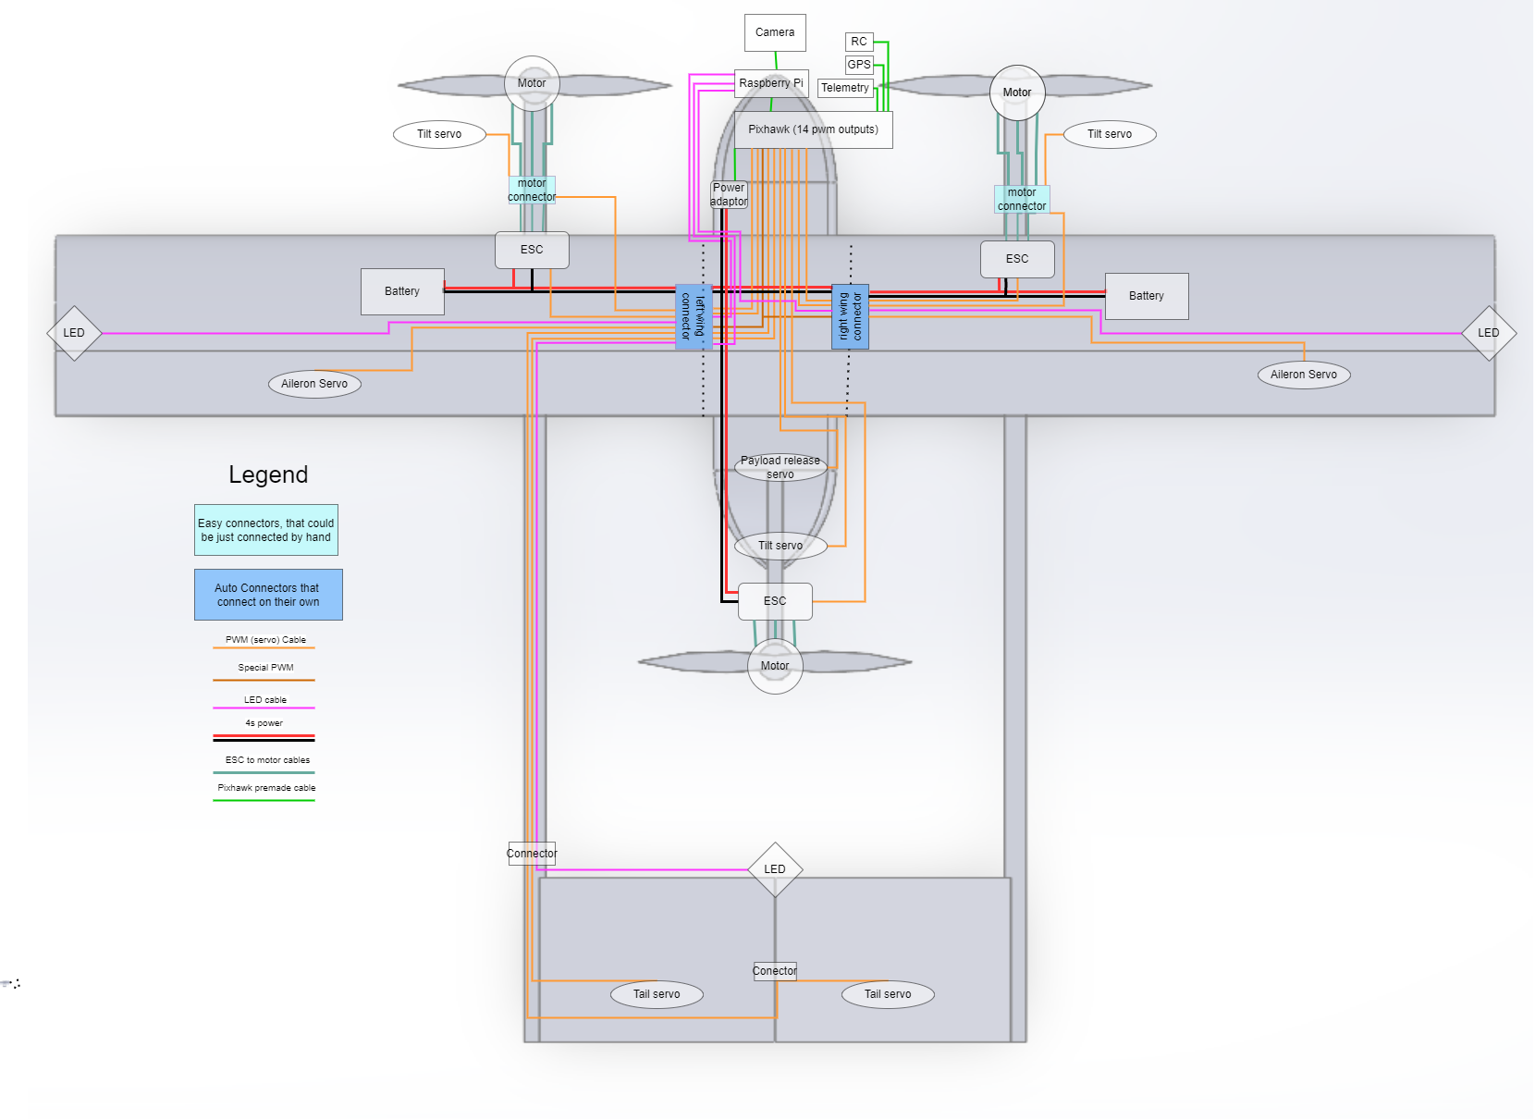

## 3-View diagram

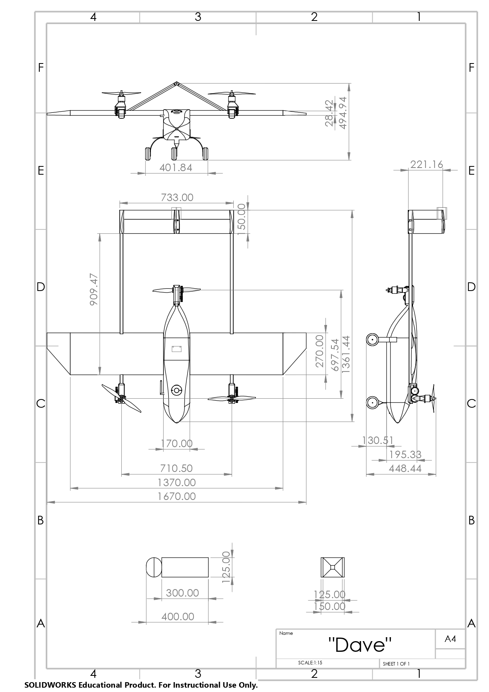

Safety

Safety is always a top priority during manufacturing and testing, with the team using proper ppe, doing risk assessments that get approved by our university and conducting tests in place with a minimal number of people like farm fields and making sure no property or bystander can get injured. The airworthiness of the system will be insured through vigorous testing of autopilot and drone performance as well as structural tests of the components.

Below is the list of Hazards that could occur during the competition, for which we are prepared.

Definitions used:

|  |  |
| --- | --- |
| **Severity** | **Examples** |
| Marginal | Irreparable damage or loss of the UAS |
| Minor | Minor Injury to a participant. Damage to public property |
| Major | Single major injury to a participant.  Single injury to a member of the public. |
| Catastrophic | Multiple injuries.  Death of any party. |

|  |  |
| --- | --- |
| **Probability** | **Example** |
| Frequent | Likely to occur frequently during the UAS challenge |
| Occasional | May occur occasionally during UAS Challenge. |
| Remote | Remote possibility of occurring during UAS Challenge. |
| Improbable | Highly unlikely to occur during UAS Challenge. |

|  |  |  |  |  |  |
| --- | --- | --- | --- | --- | --- |
| **Hazard** | **Severity** | | **Probability** | | **Mitigation** |
| Propeller strike and injury | Major | | Remote | | Externally removable link used to arm the motors on a safe side of the motors, use of ppe (gloves and glasses). A safety protocol that will not allow to approach the uas without ppe once its armed |
| Propeller hitting the ground and shattering, launching shards at team members | Minor | | Remote | | Use of glasses while in close proximity of the drone, keeping distance of at least 5 meters from the drone before motors are activated |
| Drone losing control during vertical take-off and leaning towards team members | Major | | Remote | | All team members keep a distance of at least 15 meters from the drone during launch. 1 team member will be able to initiate FTS using the rc-controller |
| Drone drifting above a person due to wind and then motors malfunction and it starts falling on someone | catastrophic | | improbable | | FTS will be activated either remotely or automatically, transitioning into forward flight mode, allowing the drone to glide away from the person before slamming the ground |
| Drone getting hit by a bird | Marginal | | improbable | | Make sure no birds are close to the take-off strip before launch |
| Use of hand tools that leads to minor injury | Minor | | Frequent | | Use of tools by trained team member and use of PPE. Work pieces will be secured properly to avoid jumping. |
| Use of power tools leading to injury | Major | Occasional | | Workpiece will be secured properly during work. Training will be provided to tool users and supervised where appropriate. Adequate PPE will be used when risks cannot be mitigated. |
| Ignition due to faulty wiring or damage of battery | Major | | Remote | | Proper storage and charging of batteries before flight using a li-ion charging and storage bags. Having a CO2 fire extinguisher on hand during testing and flight. |
| Exposure to toxic chemical during manufacturing and preparations | Minor | | Occasional | | Working with chemicals in a ventilated space with extraction units or outside. Wear safety glasses and mask. |
| Risks associated with carbon fibre material, sharp edges, small particles | Minor | Occasional | | Safe practices adopted to ensure carbon fibre doesn’t become airborne (wet sanding/Green cutting), Sufficient PPE including Safety glasses, gloves and mask. Working in an environment with  Sufficient ventilation. |
| UAV Crash due to unknown reasons | Catastrophic | | Improbable | | Conduct enough tests to make sure the UAV is reliable, do not fly above areas with people, make sure no people are on the airfield during flight |

Manufacturing

This year, with covid gone, the team received access to the university workshop and tools, so more advanced manufacturing techniques were used. Primarily, the team wanted to try to use carbon fibre composites, but knowing that this is our first time using it, the design could be changed to not use CF, however it would compromise strength and most importantly-aesthetics

Material choice

Materials were primarily chosen based on the manufacturing techniques and previous experiences as well as the goal of the project of trying more complex techniques. The materials used are:

**Carbon fibre spars:** Strong and light, relatively easy to work with requiring only cutting and rare drilling. staple of aircraft manufacturing. Unfortunately, hard to recycle at the moment, excluding the team reusing them for other projects

**Carbon fibre:** Strong and light, easy to form into complex shapes. Wet layup method is relatively cheap and easy, while still being able to produce great results. Suffers same issues as CF spars

**3mm Birch Plywood:** Cheap, easy to laser cut, saw and modify. Significantly stronger than Balsa allowing it to take some structural load. Having a honeycomb structure laser cut allows to reduce weight significantly while keeping material strong. Biodegradable.

**PET-g for 3d printing:** PLA was the next best option; however, PET-g has a higher ductile strength, allowing it to bend without shattering which is vital to our clamp connectors. It is also more heat resistant, which is important on our motor holders. PET-g is also recyclable.

**Dense XPS Foam**: Used for making the moulds for the carbon fibre parts and is kept inside the wings for extra strength. XPS foam was chosen for its rigidity, compared to other foams. It doesn't crumble which allows it to be cnc shaped, which is crucial for the mould making.it can be safely cut with a hot wire.

Carbon Fibre cutting and drilling

The carbon fibre (CF) spars need to be cut to size by team members. This must be done in a well-ventilated area ideally with an extraction unit and an adjustable vacuum, a downdraft table or a partner with a standard vacuum to capture carbon fibre dust.  Proper PPE needs to be worn glasses, at least p1 dust mask, gloves and ideally a disposable suit. Main risks include skin, eye and lung irritation as well as tiny splinters. Additional when cutting with high-speed tools may produce toxic smoke.

Cutting needs to be performed with the smallest teeth saw available to reduce chipping: a metal cutting or a perma grit hacksaw blade. Alternatively, it can be done with a Dremel or an angle grinder. Cutting of tubes needs to be performed around the tube circumference to prevent one edge breaking off. Drilling is done with a normal battery drill and a metalworking drill bit. The edges then need to be sanded with 400 grit sandpaper.

Fuselage

The shape and most strength of the fuselage is given by a 1.5 mm carbon fibre shell. First a foam positive mould is produced using a cnc router by the university technician at the university workshop. The rest is done by the team: the mould is smoothed out. The EL2 Epoxy Laminating Resin is mixed, and then applied to the foam. The mould is then wrapped in a sheet of 2x2 Twill 3k carbon fibre cloth and the cloth is then soaked with a brush. The process os repeated 3 times, after which the mould, covered in CF is put in a vacuum bag and low pressure is applied to even out the distribution of resin and get rid of excess. After the epoxy sets fully, the main hatches are cut out using a Dremel and then the positive mould is removed physically and using acetone. The surface is then smoothed out using sandpaper to decrease drag

Fuselage structure consists of 3 sheets of 3mm birch plywood that fit together with cut out teeth and are epoxied for extra strength. Laser Cutting is done using a CNC laser cutter owned by the university. The Plywood fits tightly in the shell and is attached to the fuselage using carbo fibre cloth epoxied as L shaped connectors

Connectors and spar holders are 3d printed 20% infill parts and attach to the wooden plate using m3 bolts and locking nuts. Note that depending on the printer, air temperature or humidity, parts might warp or shrink, therefore printer settings might need adjusting.

The wing holder and rear moto spars are cut to size and attached to the plywood sheet.

The off-the-shelf landing gear and payload release mechanisms, fuselage plate quick connectors, electronics and sensors are attached with M3 bolts and locking nuts.

Wings and stabilisers

All the wings and stabilisers are made the same way, similarly to fuselage. The shape of the aerofoils are laser cut by a university technician out of plywood using a cnc laser cuter. These include space for the wires running through the wing and spars. Then, team members use them as stencils to guide the hot wire to cut-out the positive moulds out of XPS Foam.

Once the sections are cut-out and combined to form the wing, the same process as with the fuselage is repeated to create a carbon fibre shell around the foam. Once the epoxy is set and vacuum bags are removed, the surface is sanded and hatches for the batteries are cut-out as well as the ailerons (or other control surfaces as is the case with the tail. The foam is removed manually to make space for the batteries and esc’s, however the rest of the foam stays, to provide extra strength and to be a medium between the spars and the wing shell.

Working with the wire cutter must be performed in a well-ventilated area preferably with an extraction unit or outside while wearing gloves and a respirator. CO2 fire extinguisher needs to be present in case of an electric fire.  
Motor mounts

The motor mount components are 3d printed, with a 30% infill. They consist of 5 separate parts, that secure around a servo motor and get attached to the end of tail spars suing screws. So far tests show that they can withstand forces 150% larger than expected.

Support equipment

The UAS will be stored in a 10mm thick plywood box filled with foam with cutouts for each specific component. The inner dimensions of the box are shown below. The ground station, consisting of a laptop, RC-transmitter and telemetry module will be stored in a separate bag. A 4mm hex head screwdriver will be used for assembly, allowing the team members to control the tension of the parts and ensuring no part is overtightened.

SKYRC IMax b6AC V2 and a li-po charging bag are used to charge batteries safely at a charge rate of 1A (maximum 6 A if needed, however less safe).

A 3d printer and the hot wire cutter will be brought to the competition, to perform maintenance on the spot, as well as basic tools

Qualification test plan

|  |  |  |  |  |
| --- | --- | --- | --- | --- |
| ID | Objective | Method | Success criteria | Test results and expected date |
| 3.1.1 | MTOW of 10.kg | Weighting the model fully loaded with dummy weighted tracker | < 10 kg | Awaiting manufacturing  (10.04) |
| 3.1.4 | Parachute activation at height > 10 m | Loading the payload into prototype and dropping from 15 m | Activation at >10 m | Awaiting manufacturing  (10.04) |
| 4.4.6 | Assemble the drone in less than 5 minutes | Disassemble the drone and assemble it while recording the time to make sure its easy to assemble | Time < 5 minutes | Awaiting manufacturing  (10.04) |
| 3.1.1 | Confirm motor thrust and power draw | Run the motor attached to a load cell test stand and a power logger | Thrust > = 2.5 kg +-10%  Powerdraw= 450W+- 10% | Awaiting motor arrival (~20.03) |
| 3.1.7 | Communication and mission planner response time tests | Fly the prototype to record  the data transmission delay and accuracy of gps | GPS position within +- 30 cm, response time within 5 seconds | Awaiting manufacturing  (10.04) |
| 3.1.9 | Test of vtol FTS | Fly the prototype to a height of 3 m and activate fts | Fts works, drone descends gently | Awaiting manufacturing  (10.04) |
| 3.1.9 | Test of horizontal flight FTS | Detach props and simulate flight on ground, activate fts | Control surfaces set to right positions, motors turn off | Awaiting manufacturing  (10.04) |
| 3.3.4 | Test the 3d printed parts strength | Applying higher than expected load in expected directions | Yielding at force higher than 150 % of expected | Parts can withstand up to 200% of expected force (Completed 02.03) |
| 3.1.8 | Test image recognition | Attach a marker to a wall and manually handle the camera to see its performance | Detection distance > 15 m, can detect colour, can predict the coordinates (accounted for marker being on wall) | The prototype flyes reliably: |